
Creating an Esri Enterprise Geodatabase

Document type | Policy/Procedure
Prepared For | Dynamic Risk
Date | September 2, 2022
Document Number | SOP-TS-00002
Revision | A
Draft Status | Draft

Suite 1110, 333 – 11th Avenue SW  Calgary, Alberta, Canada  T2R 1L9  Phone: (403) 547-8638 | www.dynamicrisk.net | Waterway Plaza Two, Suite 250  10001 Woodloch Forest Drive  The Woodlands, TX 77380  Phone: (832) 482-0606

This document contains 7 pages.

Revision Log
Rev. | Date | Description of Revision
0 | September 2, 2022 | Initial Draft

Signatures
Prepared for | Company Name
Prepared by | Signature
Prepared by | Karen Bowes  Safety Coordinator, Dynamic Risk
Approved by | Signature
Approved by | Name  Title, Company

Document Control
x  ¨ | Strictly Confidential. No distribution without permission from Dynamic Risk.  Unrestricted Distribution.

Contents
Revision Log ……………………………………………………………………………………………………………………………………..ii
Signatures ……………………………………………………………………………………………………………………………………..ii
Contents ……………………………………………………………………………………………………………………………………..iii
1 Purpose 1
1.1 Example 1
2 Scope 1
3 Policy Statement 1
3.1 Example 1
4 Definitions 1
5 Responsibilities 2
6 Procedures 2
6.1 Creating a Geodatabase on an Oracle Server 2
6.1.1 Create SDE User and Tablespace 2
6.1.2 Create the Geodatabase 3
6.1.3 Configure Oracle EXTPROC file 7
6.2 Creating a Geodatabase in Microsoft SQL Server 13
7 Document Approvals 15
8 Revision History 16

Purpose
This procedure establishes guidelines for the business process by which employees can create a spatial geodatabase using ArcGIS pro on an Oracle or Microsoft SQL server database.

Scope
Development Operations
- Database Administrators

Policy Statement

Definitions

Responsibilities
- DBAs are responsible for creating or removing geodatabases

Procedures
This section of the document outlines the process by which DBAs can create a geodatabase on an Oracle or SQL Server database.

Enable Creation of ESRI Enterprise Geodatabase in Oracle Server

Create SDE User and Tablespace
- Execute the query below in SQL*PLUS or SQL Developer. If you do not get the results below, then an ESRI geodatabase does not exist or has not been enabled on the server.
SELECT sde.ST_AsText(SDE.ST_Geometry('POINT (10 10)', 0)) FROM DUAL;
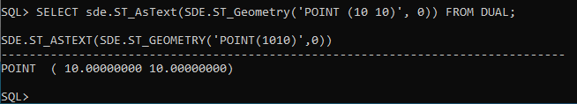
- Create the tablespace for the SDE user. This tablespace will be used for the geodatabase repository.
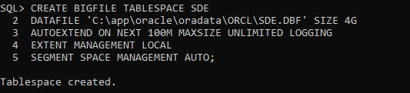

- Create an SDE user and set the default tablespace of the SDE user to the SDE tablespace with unlimited quota
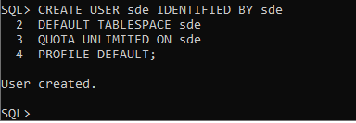

- Grant the object and system privileges needed to create the geodatabase and update the geodatabase to the SDE user. Connect as the SYS user and copy and paste the following commands into SQLPLUS or SQL DEVELOPER.
GRANT EXECUTE ON dbms_pipe TO public;
GRANT EXECUTE ON dbms_lock TO public;
GRANT EXECUTE ON dbms_lob TO public;
GRANT EXECUTE ON dbms_utility TO public;
GRANT EXECUTE ON dbms_sql TO public;
GRANT EXECUTE ON utl_raw TO public;
GRANT EXECUTE ON DBMS_CRYPTO TO sde;

GRANT CREATE SESSION,
CREATE TABLE,
CREATE VIEW,
CREATE PROCEDURE,
CREATE SEQUENCE,
CREATE TRIGGER,
CREATE TYPE,
CREATE INDEXTYPE,
CREATE LIBRARY,
CREATE PUBLIC SYNONYM,
DROP PUBLIC SYNONYM,
ADMINISTER DATABASE TRIGGER,
CREATE OPERATOR
TO SDE;

Create the Geodatabase
- Start ArcMap or ArcCatalog. On the ‘Contents’ panel (left panel) under ‘Projects’, right click on ‘Databases’. Select ‘New Database Connection’.
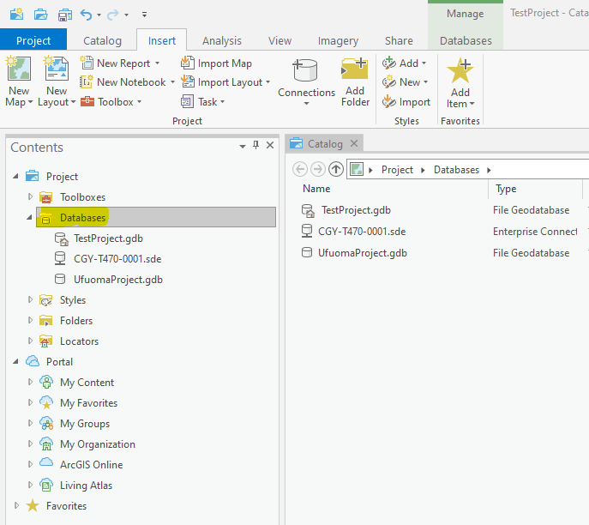

- Connect to the Oracle database as the SDE user. The ‘Database Platform’ field should be set to ‘Oracle’. In the ‘Instance’ name field, specify the tnsname of the pluggable database or the single-container database where the SDE user resides. Be sure to click the checkbox to save the username and password.

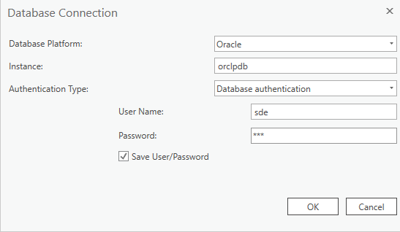

- Right-click the newly created database connection and click ‘Enable Enterprise Geodatabase’
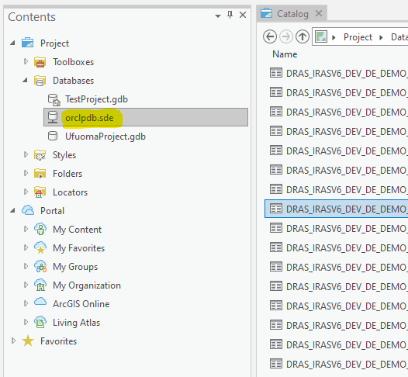

- Select the database connection that was created in STEP 4 and highlighted in STEP 5. Click the file explorer icon next to the ‘Authorization File’ field and enter the location of the authorization ‘keycodes’ file. Click ‘Run’.
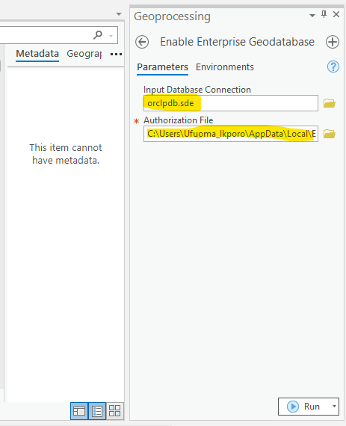

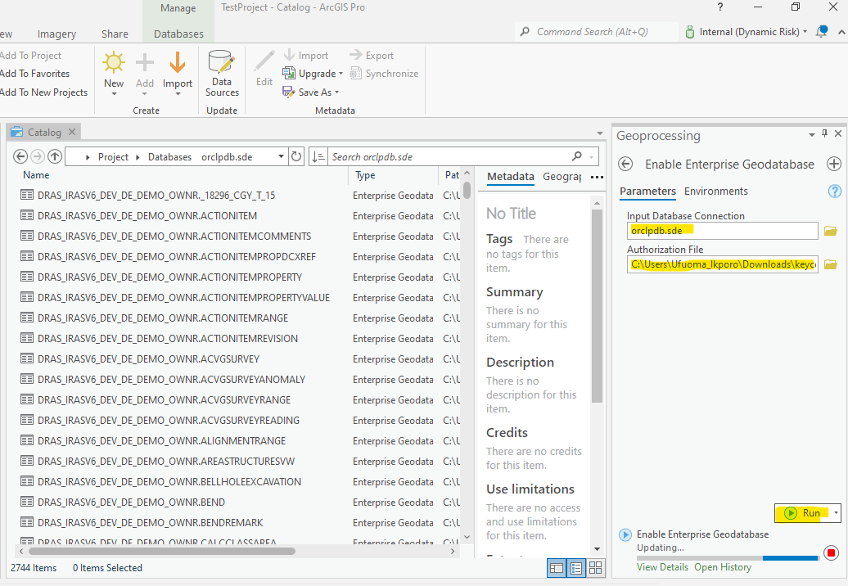

- The geodatabase creation should complete with the following warnings. As long as the message ‘Finished creating geodatabase schema’ is displayed, we can continue on to the next step
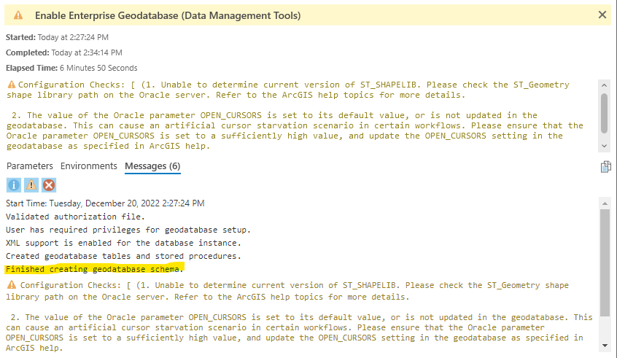

Configure Oracle EXTPROC file
Configure the Oracle extproc.ora file to access the Esri ST libraries. The SQL functions of ST_Geometry and ST_Raster require access to these shared libraries through the Oracle external procedure agent (extproc). The 2 shared library files are the
- st_shapelib.dll (for ST_Geometry)
- libst_raster_ora.dll (for ST_Raster)
The shared library dll files mentioned above can be found in the directory where the ArcGIS server or ArcMap clients are installed. It can also be downloaded from My Esri. The dll files can be found within the following directory on the server where the ArcGIS server installation was installed.
Installation directory>\ArcGIS\Server\DatabaseSupport\Oracle\Windows64
The following steps outline the procedure for configuring the extproc.ora file to access the ST libraries
- Copy the ST_Geometry and ST_Raster dll files (st_shapelib.dll and libst_raster_ora.dll) to a known location on the Oracle server
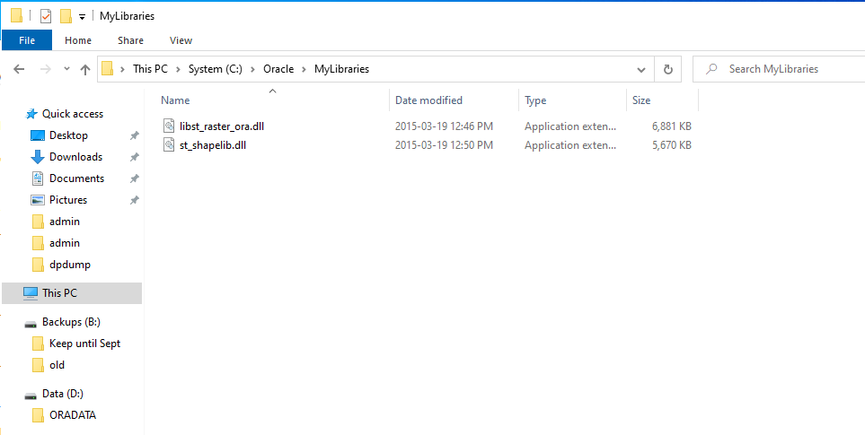

- Go to the location of the extproc.ora and make a backup copy of the file before making any changes to it. The extproc.ora file can be found in the following directory
%ORACLE_HOME%\hs\admin
The following query can be used to find the location of the Oracle home for a database
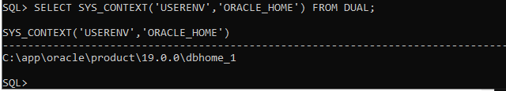
- Modify the extproc.ora file to include the setting for the EXTPROC_DLLS environment variable, which specifies the location of the ST library dlls from STEP 1. Be sure to add a double backslash ‘\\’ instead of a single backslash ‘\’ to the directory path of the dlls

SET EXTPROC_DLLS=ONLY:C:\\Oracle\\MyLibraries\\st_shapelib.dll;C:\\Oracle\\MyLibraries\\libst_raster_ora.dll
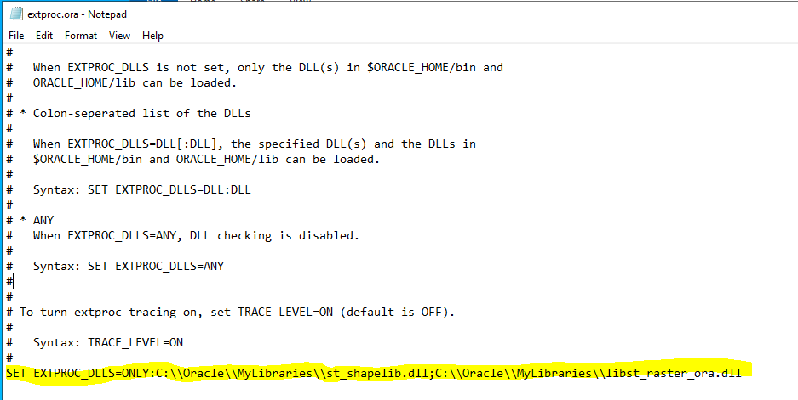

- Go to the location of the tnsnames.ora file and save a backup copy of the file before making any modifications to the originalfile. The tnsnames.ora file can be found in the following directory
%ORACLE_HOME%/network/admin/tnsnames.ora
- Modify the tnsnames.ora file by copying and pasting the following entry into the file. Save and close the file

EXTPROC_CONNECTION_DATA =
(DESCRIPTION =
(ADDRESS_LIST =
(ADDRESS = (PROTOCOL = IPC)(Key = EXTPROC1))
)
(CONNECT_DATA =
(SID = PLSExtProc)
(PRESENTATION = RO)
)
)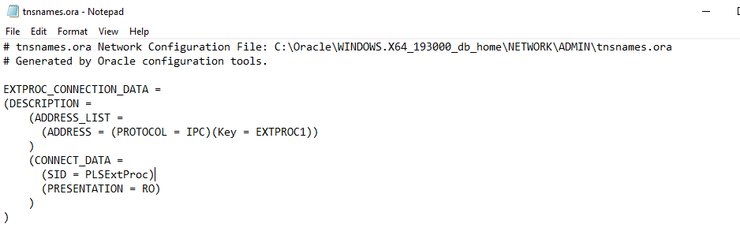
- Create a backup copy of the listener.ora file before modifying the original file. The listener.ora file can be found in the following directory
%ORACLE_HOME%/network/admin/tnsnames.ora
- Modify the listener.ora file adding a SID_LIST_LISTENER entry
- Add the ADDRESS parameter for the extproc agent. This should match the ADDRESS parameter in the tnsnames.ora file
- Add the oracle home location to the ORACLE_HOME parameter under the SID_LIS_LISTENER
- The directory paths in the ENVS entry to the location of the ST_Geometry (st_shapelib) and st_raster shared library dll files (separated by semi-colon)

**********************************************************************************
LISTENER =
(DESCRIPTION_LIST =
(DESCRIPTION =
(ADDRESS = (PROTOCOL = TCP)(HOST = Ora12c.cgy.dynamicrisk.net)(PORT = 1521))
(ADDRESS = (PROTOCOL = IPC)(KEY = EXTPROC1))
)
)

SID_LIST_LISTENER =
(SID_LIST =
(SID_DESC =
(SID_NAME = PLSExtProc)
(ORACLE_HOME = C:\Oracle\product\12.1.0\dbhome_1)
(PROGRAM = extproc)
(ENVS="EXTPROC_DLLS=C:\Oracle\MyLibraries\st_shapelib.dll;C:\Oracle\MyLibraries\libst_raster_ora.dll")
)
)
**********************************************************************************
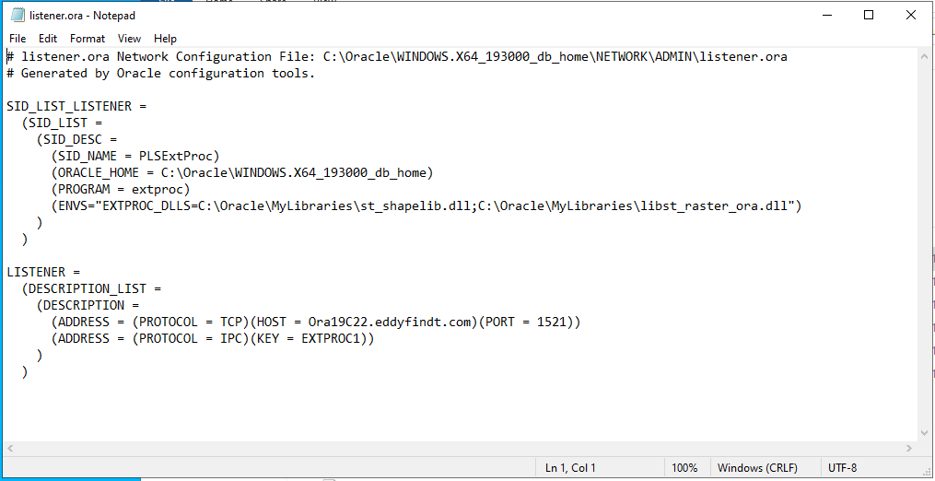

- Restart the Oracle listener to take in the changes that were made to the listener.ora file. Type ‘Services’ into the windows search bar to open the Windows Services application. Look for the Oracle listener and click restart to restart the Oracle Listener service
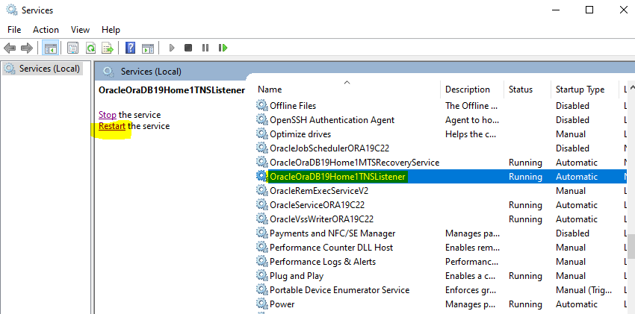

- CONNECT to the Oracle database as the SDE user using either SQLPLUS or SQL DEVELOPER for the subsequent steps. Copy and execute the queries below. If the path displayed for the ST_SHAPELIB and LIBST_RASTER dll files are, you must recreate the library to point to the correct location of the library files.

SELECT file_spec
FROM user_libraries
WHERE library_name = 'ST_SHAPELIB';

SELECT file_spec
FROM user_libraries
WHERE library_name = 'LIBST_RASTER';

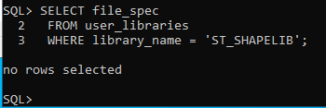
- Enter the following command to recreate and point the ST_SHAPELIB and ST_RASTER libraries to the location of the ST_Geometry library files (st_shapelib.dll, and libst_raster_ora.dll).

CREATE or REPLACE LIBRARY ST_SHAPELIB AS ' C:\Oracle\MyLibraries\st_shapelib.dll '
/

CREATE OR REPLACE LIBRARY libst_raster AS 'C:\Oracle\MyLibraries\libst_raster_ora.dll';
/
/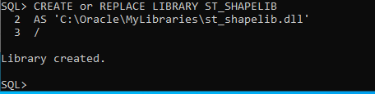

- Recompile the ST_GEOMETY_SHAPELIB package (needs to be done each time the ST_SHAPELIB library is created or modified)

ALTER PACKAGE sde.st_geometry_shapelib_pkg COMPILE
REUSE SETTINGS;

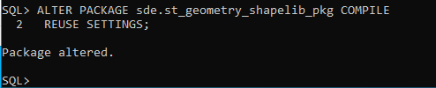

- Execute the following query the SDE user to verify that Oracle extproc agent has been properly configured to access the geodatabase. If the query returns an error, go through the steps to configure the Oracle extproc process again to make sure that the correct paths were entered, and the correct entries were modified appropriately in each step. If the Oracle extproc is properly configured, the query should return the result in the image below

SELECT sde.ST_AsText(SDE.ST_Geometry('POINT (10 10)', 0)) FROM DUAL;

Enable Creation of ESRI Enterprise Geodatabase in Microsoft SQL Server
- Open ArcGIS Pro application and search for ‘create enterprise geodatabase’ in the command search bar
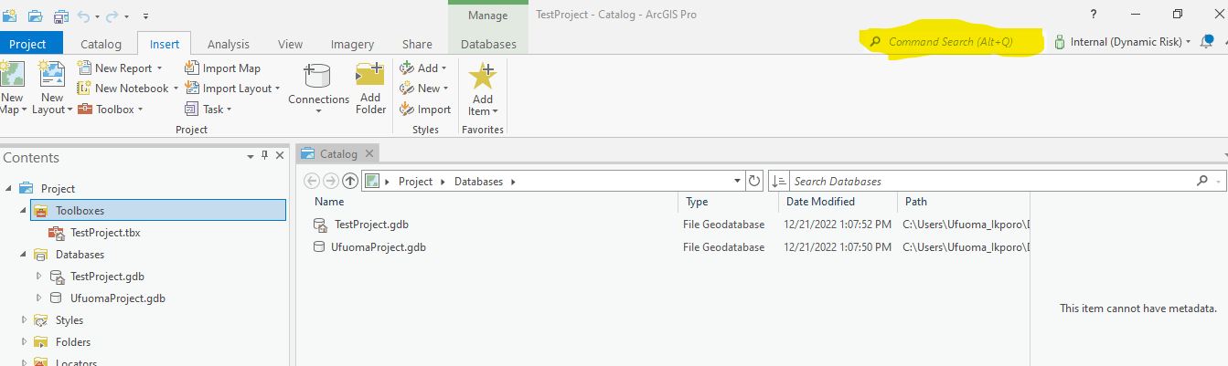

- In the Geoprocessing panel that appears, set the ‘Database Platform’ field to ‘SQL Server’. For the ‘Instance’ enter the SQL server instance name. for the ‘Database’ field, enter the name of the database where you would like the geodatabase to be stored. If the database name entered does not exist on the instance specified, it will be automatically created. Check off ‘Operating System Authentication’ if operating system authentication has been set up and if your operating system login is part of the sysadmin fixed server role on SQL Server. Select the ‘Sde Owned Schema’ checkbox if you want the geodatabase to be created in the SDE schema. Uncheck the ‘Sde Owned Schema’ checkbox if you want the geodatabase to be created in the DBO schema. The geodatabase administrator is the owner of the schema where the geodatabase is created. For the ‘Geodatabase Administrator Password’ field, set the password for the SDE user. Click the folder icon next to the ‘Authorization File’ field and enter the location of the ‘keycodes’ file. Click ‘Run’ to create the geodatabase
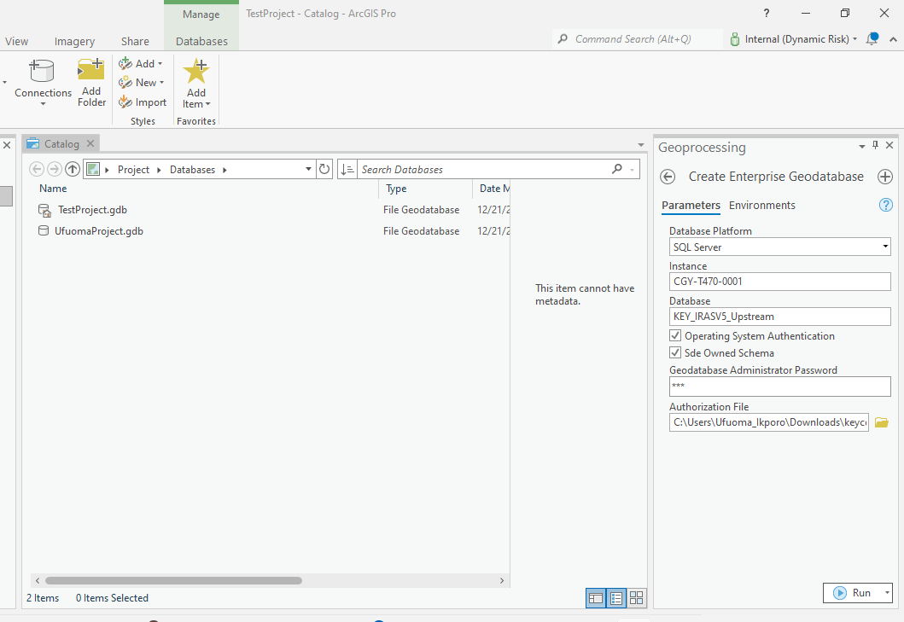

The following message will be displayed upon completion
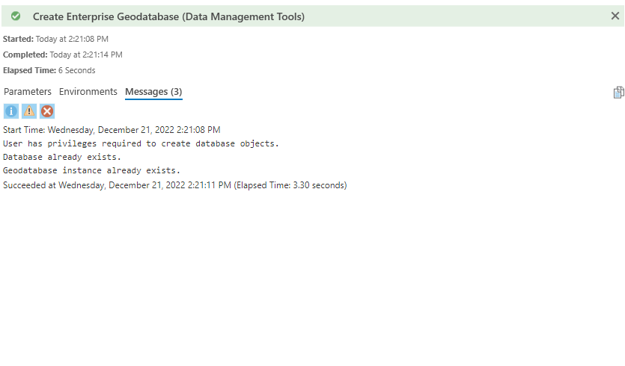

Document Approvals
Contains the information necessary to show evidence of approvals for policies and procedures documents. You will find this section after the title page in this document.

Revision History
Describes changes, or updates, to a policy or procedure. A history of changes serves as a reference to the reader to understand any changes made to a policy or procedure. In addition, a list of document changes can be useful for metrics, measurements, and audit purposes. You will find this section after the title page in this document.

